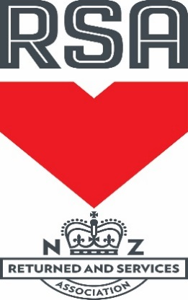
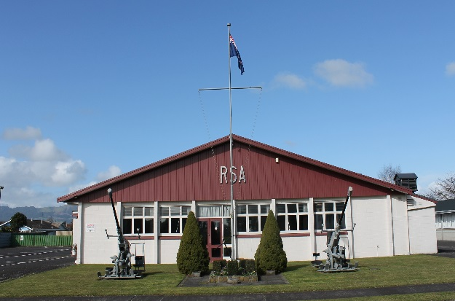
Matamata RSA
Newsletter
APRIL 2016

Dates for your diary:
Friday 1st April – RSA v New World 8 ball competition starts 7 pm
Poppy day Friday 22nd April – we still require more helpers to sell poppies. If you are able to help please let us know. Elaine Young is co-ordinating the day.
Cemetery Working Bee Saturday 23rd at 10.00 a.m. Please see Peter Love or Graeme Waterson if you are able to help.
ANZAC Day Monday 25th April – Club will be open at 5 a.m
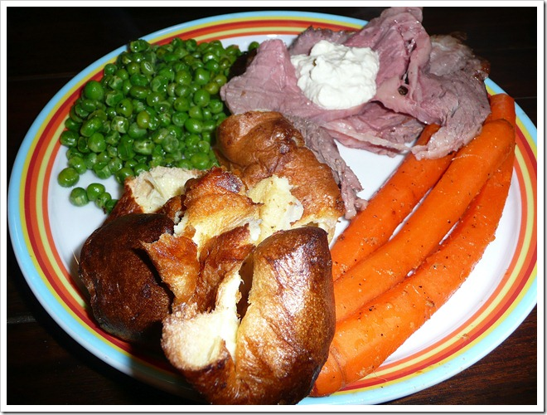
Sunday roast will be on the 8th May at 6.00 pm. This is Mothers Day so treat the ladies on their special day. Bookings essential by Thursday 5th May. $18 a head for a roast meal and dessert.
Committee Members
Your new committee: President: Debbie Martin, Vice-President: Ross Campbell, Committee members: Sue Coatham, Clive Collingwood, Murray Couch, Dick Larkin, Peter Love, Anne Tingle, Wendy Villiers, and Past President Graeme Waterson.

Gaming Machines – For those who were not at the AGM the Department of Internal Affairs has revisited our situation and are now prepared to consider a further 12 months renewal of our gaming license.

New Health & Safety Legislation – On April 4th more legislation will come into force regarding Health & Safety Law. This will not affect members greatly but we need to ensure members and visitors do not enter any of the areas marked ‘Staff Only” which is the kitchen and bar areas. If you see anything around the Club that you feel would be a safety issue, please notify myself or Sue immediately. The Club is responsible for all staff, members and guests whilst they are on the premises. If you have any questions, please ask me.

Sky Sport: During April on Sky we will be showing
Warriors Games
3rd April Warriors v Roosters 4.00 pm
9th April Warriors v Sea Eagles 7.30 pm
16th April Warriors v Bulldogs 7.30 pm
Chiefs Games
8th April Chiefs v Blues 7.30 pm
23rd April Chiefs v Hurricanes 7.30 pm
29th April Chiefs v Sharks 7.30 pm
Inter-Club 8 Ball competition – will be commencing Monday 11th April. If you would like to play with the RSA team, please write your name on the list on the board. There is some travel involved when the team is playing at another venue. If you have any questions, please see Lee Sadler or Murray Couch.

Badges for Sale
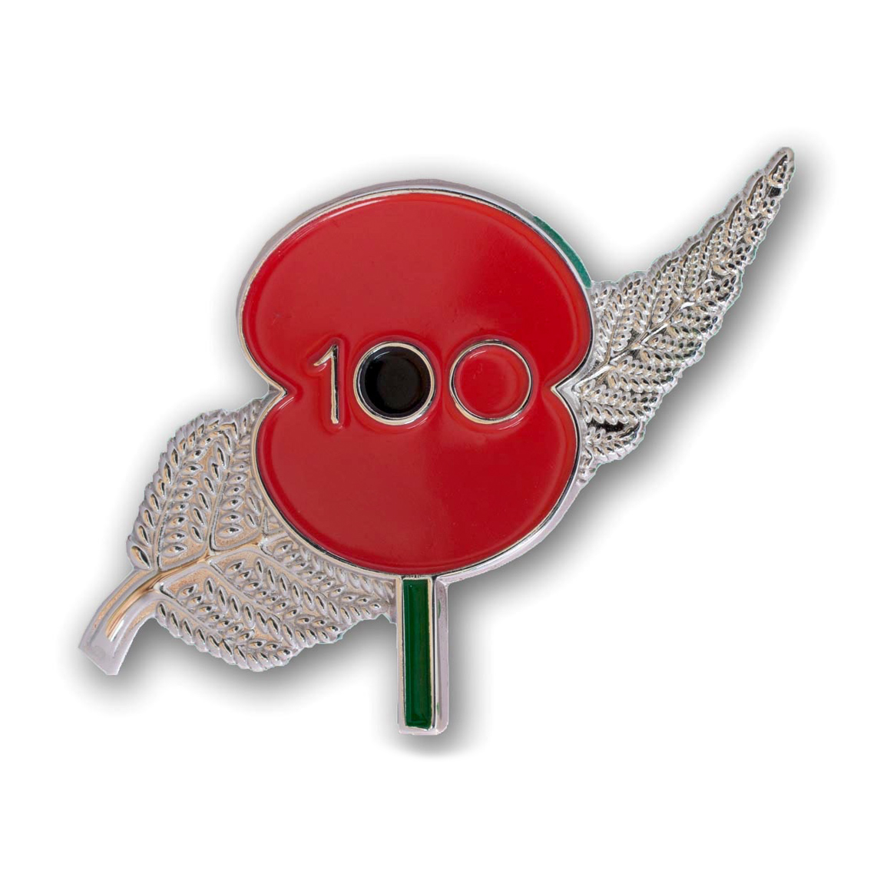
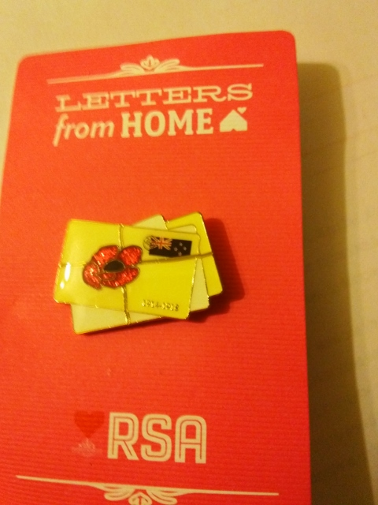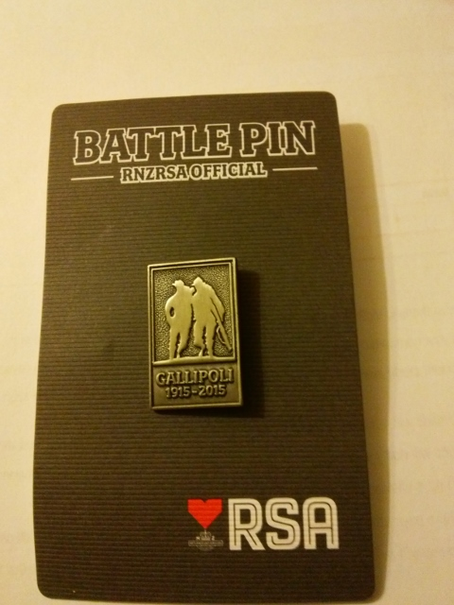
$8.00 each
Available from the Bar

To keep you smiling!
A truck driver was driving along a country road. A sign came up that read “Low Bridge Ahead”. Before he realised it, the bridge was directly ahead and he was stuck under it. Cars were backed up for miles. Finally, a Police car arrived. The police officer got out of his car, walked to the truck’s cab, and said to the driver, “Got stuck, hey”. The truck driver said, “No, I was delivering this bridge and ran out of diesel”.

A lady was picking through the frozen chickens at a store but she couldn’t find one big enough for her family. She asked a passing assistant, “Do these chickens get any bigger?” The assistant replied, “I’m afraid not, they’re dead”.

Our sponsor for the Thursday night members draw
for April is Matamata Tyre Service


A reminder to all members that they must have their member’s cards on them at all times while at the club and that all visitors (this includes partners) must be signed in. This is a legal requirement.
If you are looking for information about what is happening in your club check out the website: www.matamatarsa.co.nz and the password is matarsa. We also now have a Facebook
Page, so please check this out.
Tricia

