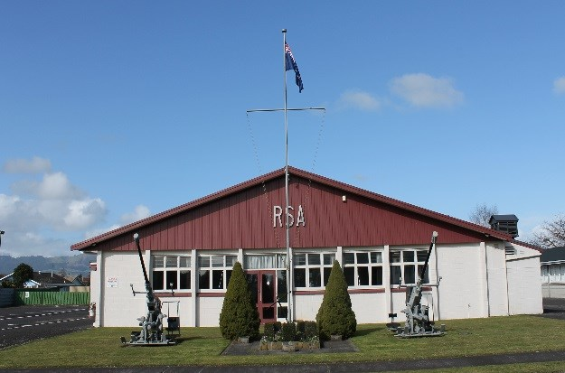

We pride ourselves for being a modern RSA that values our past but embraces our future.
We are family friendly and cater for all age groups.
Diary Dates
Sunday 20 January - Club closed for Committee and Staff Function.
Monday 28 January - Auckland Anniversary Day. The Club will open at 11.00 am with a BBQ Lunch provided at 12.30 pm. Everyone welcome.
Raffles, Membership Draw, Lucky Draw and Steeny’s Draw are all still happening during January.
Friday 1 February - Elusive Joker and 8 ball - RSA vs New World begins.
Wednesday 13 February - Housie starts.
Friday 15 February - Cocktail Night – Dress up in your finest and come and try our cocktails. Prizes for the best dressed.
Sunday 24 February - Sunday Roast at 6.00 pm. Bookings to the bar or phone 888 7190.
Killer Pool – Every Sunday (except 20 January) - Names in by 3.45 pm - Play starts at 4.00 pm - $5.00 entry - Winner takes all.
Kitchen re-opens on Thursday 10 January 2019
Bar snacks are available every day from the bar while the kitchen is closed.

Steeny’s Tuesday Night Draw at 7.00 pm
Purchase any drink on Tuesday night and go in the draw to win $100
You must be present to claim the prize
1 ticket per person
Sponsored by Brian Steen –Matamata Tyre Service

The membership subscriptions for 2019 are now due and payable by 31 January 2019. Your cards are available for pick-up from the bar.

To keep you smiling!
A new year’s resolution is something that goes in one year and out the other. - Anonymous
This New Year I’m going to make a resolution I can keep: no dieting all year long.
- Melanie White
Women get a little more excited about New Year’s Eve than men do. It’s like an excuse: you drink too much, you make a lot of promises you’re not going to keep; the next morning as soon as you wake up you start breaking them. For men, we just call that a date.
- Jay Leno
My New Year’s resolution is to eat better, so from now on, I’m going to only date guys who can afford to take me somewhere other than McDonalds. - Melanie White
If you make a New Year’s resolution to eat a healthy diet, and you keep it, you won’t actually live longer, but it will seem longer.
- Greg Tamblyn

Our sponsor for the Thursday night Members’ Draw for January is

Fairview Motors Limited
If you are looking for information about what is happening in your club check out the website: www.matamatarsa.co.nz and the password is matarsa or our Facebook Page and click on share, which will get more people to know about what is happening and us. We are also on Neighbourly.co.nz.
Tricia

